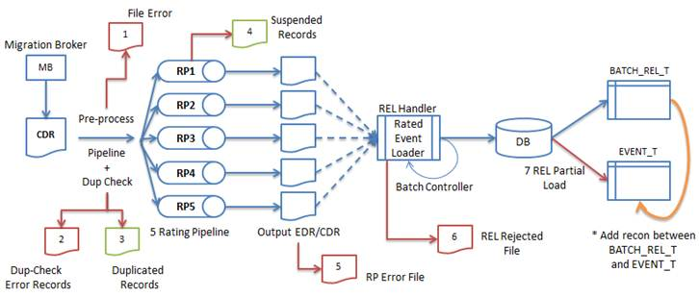

|  |  |  |  |  |  |
| --- | --- | --- | --- | --- | --- |
| **No** | **PROCESS** | **ACTIVITY** | **REFERENCE** | **PIC** | **TIME/DATE** |
| 1 | MIGRATION BROKER | Sent the processed CDR from Medicon to BRM. |  |  |  |
| 2 | CDR | 1) CDR is the details of the data usage by customers which are to be rated and billed  2) Call detail record (CDR) is receive daily from Medicon and these cdr will be rated in pipeline based on their usage for each file.  3) Daily CDR from Medicon received in respective folder. |  |  |  |
| 3 | PRE-PROCESS | The CDR file will be preprocess in order to:   * Check for cdr formatting * Check for duplicate sequence number * Create recon table for the file * Rename file extension from (.cdr.ext) to (.cdr)   The output from the pre process will be move to respective output directories. |  |  |  |
| 4 | DUPLICATE CHECK | 1) Check for duplicates, whether the CDR already processed or not.  2) There is a script that will count the cdr and calculate gross amount from the file.  3) The output of the duplicate checking will be sent to directories. |  |  |  |
| 5 | RATING PIPELINES | 1) Rate the CDR file with extension (.edr) according to their usage and rate. This is the part where amount of charges will be applied to the customers.  2) File will be rated according to the amount used and rate assigned to the user in each RP  3) The output of these CDR files will change extension from (.edr) to (.out)  4) Rating Pipeline will also process suspended CDR files. |  |  |  |
| 6 | OUTPUT CDR | Output rating pipelines will be moved to designated directory which depends on result of the output of the file. |  |  |  |
| 7 | REL handler | 1) Load CDR files to Database system.  2) Change the extension of the CDR file from (.out) to (.out.bc). It is done by script in REL directory.  3) Move the CDR files from NEW directory to REL directory for REL process.  4)Move the CDR files that having error during REL process to their respective rejected directories.  After the CDR file had been loaded into Database, it will be archive into archive directory for successful rated CDR, or reject directory for rejected CDR files |  |  |  |
|  |  |  |  |  |  |
|  |  |  |  |  |  |